Your Paper's Title Starts Here: Please Center, Use TNR 20pt., Bold (In English!!)
Full First Author¹, Full Second Author^{2, *} and Full Third Author³ (TNR 12pt., centered)
¹Full affiliation of first author, including country (in English, TNR 10pt. centered)
²Full affiliation of second author, including country (in English)
³List all affiliation in the same way (in English)
*Corresponding author
Abstract.
Here write the abstract - 200 – 300 words in English! (TNR 12 pt. alignment in block, spacing 1,0) Abstract should outline background of the study, objectives, methodology, results, and conclusions. text, text, text, text, text, text, text, text, text, text, text, text, text, text, text, text, text, text, text, text, text, text, text, text, text, text, text, text, text, text, text, text, text, text, text, text, text, text, text, text, text, text, text, text, text, text, text, text, text, text, text, text, text, text, text, text, text. text, text, text, text, text, text, text, text, text, text, text, text, text, text, text, text, text, text, text, text, text, text, text, text, text, text, text, text, text, text, text, text, text, text, text, text, text, text, text, text, text, text, text, text, text, text, text, text, text, text, text, text, text, text, text, text, text.
Keywords: key word, key word, key word (max 5 key words in English)

Introduction (TNR 14pt., bold)
The main text, (TNR 12pt., alignment in block, spacing 1,0) text, text, text, text, text, text, text, text, text, text, text, text, text, text, text, text, text, text, text, text, text, text, text, text, text, text, text, text, text, text, text, text, text, text, text, text, text, text, text, text, text, text, text, text, text, text, text, text, text, text, text, text, text.
Figure 1: Figure description (TNR 10pt., centered, italics)
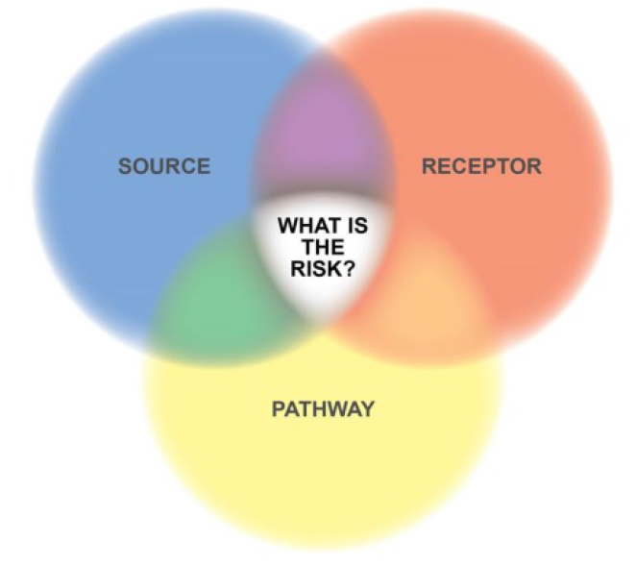
Source: (TNR 10pt. italics)
Text, text, text, text, text, text, text, text, text, text, text, text, text, text, text, text, text, text, text, text, text, text, text, text, text, text, text, text.
Table 1: Table description (TNR 10pt., italics)
Times New Roman 10pt | Times New Roman 10pt | Times New Roman 10pt
Times New Roman 10pt | Times New Roman 10pt | Times New Roman 10pt
Times New Roman 10pt | Times New Roman 10pt | Times New Roman 10pt
Times New Roman 10pt | Times New Roman 10pt | Times New Roman 10pt

Source: (TNR 10pt., italics)
Equations
Equations (refer with: Eq. 1, Eq. 2,...) should be placed in the middle, denoted by numbers in round parentheses and transformed by equation conversion manager, do not use Print Screen or jpg format. For example:
D = b2 - 4ac (1)

Body of paper (TNR 14pt., bold)
The article must be divided into chapters such as Introduction, Methods, Results and Discussion (TNR 12pt., alignment in block, spacing 1,0).

Conclusion (TNR 14pt., bold)

Acknowledgment (TNR 12pt. bold)
This paper is an output of the science project…

References (TNR 14pt., bold)
All works listed in references must be a reference in the paper (TNR 12pt., alignment in block, spacing 1,0). All citations in the text and all references must meet APA styles (American Psychological Association 7th edition – more information http://www.apastyle.org/).

Footnote TNR 10pt.

